Cropping an Image
To extract a rectangular portion of an image, use the imcrop function. imcrop accepts two primary arguments:
- The image to be cropped
- The coordinates of a rectangle that defines the crop area
If you call imcrop without specifying the crop rectangle, you can specify the crop rectangle interactively. In this case, the cursor changes to crosshairs when it is over the image. Position the crosshairs over a corner of the crop region and press and hold the left mouse button. When you drag the crosshairs over the image you specify the rectangular crop region. imcrop draws a rectangle around the area you are selecting. When you release the mouse button, imcrop creates a new image from the selected region.
In this example, you display an image and call imcrop. The imcrop function displays the image in a figure window and waits for you to draw the cropping rectangle on the image. In the figure, the rectangle you select is shown in red. The example then calls imshow to view the cropped image.
imshow circuit.tif
I = imcrop;
imshow(I);
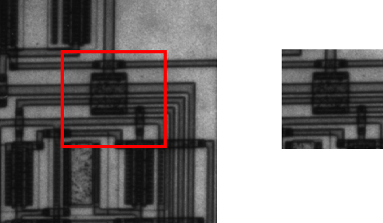

Performing General 2-D Spatial Transformations
This section describes two toolbox functions that you can use to perform general 2-D spatial transformations. (For information about performing transformations of arrays of higher dimension, see Performing N-Dimensional Spatial Transformations.)
- maketform
- imtransform
You use the maketform function to define the 2-D spatial transformation you want to perform. maketform creates a MATLAB structure called a TFORM that contains all the parameters required to perform the transformation. You can define many types of spatial transformations in a TFORM, including affine transformations, such as translation, scaling, rotation, and shearing, projective transformations, and custom transformations. For more information, see Creating TFORM Structures. (You can also create a TFORM using the cp2tform function — see Image Registration)
After you create the TFORM, you use the imtransform function to perform the transformation, passing imtransform the image to be transformed and the TFORM structure. The following figure illustrates this process. The next section provides an example that illustrates each step — see Example: Performing a Translation.

Overview of General 2-D Spatial Transformation Process
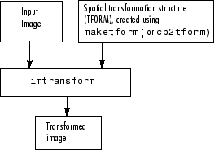

Example: Performing a Translation
This example illustrates how to use the maketform and imtransform functions to perform a 2-D spatial transformation of an image. The example performs a simple affine transformation called a translation. In a translation, you shift an image in coordinate space by adding a specified value to the x- and y-coordinates. The example illustrates the following steps:
- Step 1: Import the Image to Be Transformed
- Step 2: Define the Spatial Transformation
- Step 3: Create the TFORM Structure
- Step 4: Perform the Transformation
- Step 5: View the Output Image

Step 1: Import the Image to Be Transformed
Bring the image to be transformed into the MATLAB workspace. This example creates a checkerboard image, using the checkerboard function. By default, checkerboard creates an 80-by-80 pixel image.
cb = checkerboard;
imshow(cb)

Original Image
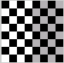

Step 2: Define the Spatial Transformation
You must define the spatial transformation that you want to perform. For many types of 2-D spatial transformations, such as affine transformations, you can use a 3-by-3 transformation matrix to specify the transformation. You can also use sets of points in the input and output images to specify the transformation and let maketform create the transformation matrix. For more information, see Defining the Transformation Data.
This example uses the following transformation matrix to define a spatial transformation called a translation.
xform = [ 1 0 0
0 1 0
40 40 1 ]
In this matrix, xform(3,1) specifies the number of pixels to shift the image in the horizontal direction and xform(3,2) specifies the number of pixels to shift the image in the vertical direction.

Step 3: Create the TFORM Structure
You use the maketform function to create a TFORM structure. As arguments, you specify the type of transformation you want to perform and the transformation matrix (or set of points) that you created to define the transformation. For more information, see Creating TFORM Structures.
This example calls maketform, specifying 'affine' as the type of transformation, because translation is a type of affine transformation, and xform, the transformation matrix created in step 2.
tform_translate = maketform('affine',xform);

Step 4: Perform the Transformation
To perform the transformation, call the imtransform function, specifying the image you want to transform and the TFORM structure that stores all the required transformation parameters. For more information, see Performing the Spatial Transformation.
The following example passes to the imtransform function the checkerboard image, created in Step 1, and the TFORM structure created in Step 3. imtransform returns the transformed image.
[cb_trans xdata ydata]= imtransform(cb, tform_translate);
The example includes two optional output arguments: xdata and ydata. These arguments return the location of the output image in output coordinate space. xdata contains the x-coordinates of the pixels at the corners of the output image. ydata contains the y-coordinates of these same pixels.
Note This section uses the spatial coordinate system when referring to pixel locations. In the spatial coordinates system, the x- and y-coordinates specify the center of the pixel. For more information about the distinction between spatial coordinates and pixel coordinates, see Coordinate Systems.
The following figure illustrates this translation graphically. By convention, the axes in input space are labeled u and v and the axes in output space are labelled x and y. In the figure, note how imtransform modifies the spatial coordinates that define the locations of pixels in the input image. The pixel at (1,1) is now positioned at (41,41). (In the checkerboard image, each black, white, and gray square is 10 pixels high and 10 pixels wide.)

Input Image Translated
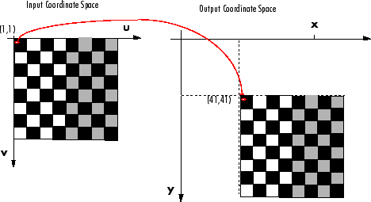
Pixel Values and Pixel Locations. The previous figure shows how imtransform changes the locations of pixels between input space and output space. The pixel located at (1,1) in the input image is now located at (41,41) in the output image. Note, however, that the value at that pixel location has not changed. Pixel (1,1) in the input image is black and so is pixel (41,41) in the output image.
imtransform determines the value of pixels in the output image by mapping the new locations back to the corresponding locations in the input image (inverse mapping). In a translation, because the size and orientation of the output image is the same as the input image, this is a one to one mapping of pixel values to new locations. For other types of transformations, such as scaling or rotation, imtransform interpolates within the input image to compute the output pixel value. For more information about the interpolation methods used by imtransform, see Interpolation.

Step 5: View the Output Image
After performing the transformation, you might want to view the transformed image. The example uses the imshow function to display the transformed image.
figure, imshow(cb_trans)

Translated Image
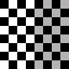
Understanding the Display of the Transformed Image. When viewing the transformed image, especially for a translation operation, it might appear that the transformation had no effect. The transformed image looks identical to the original image. However, if you check the xdata and ydata values returned by imtransform, you can see that the spatial coordinates have changed. The upper left corner of the input image with spatial coordinates (1,1) is now (41,41). The lower right corner of the input image with spatial coordinates (80,80) is now (120,120). The value 40 has been added to each, as expected.
xdata =

41 120

ydata =

41 120
The reason that no change is apparent in the visualization is because imtransform sizes the output image to be just large enough to contain the entire transformed image but not the entire output coordinate space. To see the effect of the translation in relation to the original image, you can use several optional input parameters that specify the size of output image and how much of the output space is included in the output image.
The example uses two of these optional input parameters, XData and YData, to specify how much of the output coordinate space to include in the output image. The example sets the XData and YData to include the origin of the original image and be large enough to contain the entire translated image.
Note All the pixels that are now in the output image that do not correspond to locations in the input image are black. imtransform assigns a value, called a fill value, to these pixels. This example uses the default fill value but you can specify a different one — see Specifying Fill Values.
cb_trans2 = imtransform(cb, tform_translate,...
'XData',[1 (size(cb,2)+xform(3,1)],...
'YData', [1 (size(cb,1)+xform(3,2)]);
figure, imshow(cb_trans2)

View of the Translated Image in Relation to Original Coordinate Space
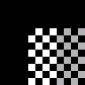

Defining the Transformation Data
Before you can perform a spatial transformation, you must first define the parameters of the transformation. The following sections describe two ways you can define a spatial transformation.
- Using a Transformation Matrix
- Using Sets of Points
With either method, you pass the result to the maketform function to create the TFORM structure required by imtransform.

Using a Transformation Matrix
The maketform function can accept transformation matrices of various sizes for N-D transformations. Because imtransform only performs 2-D transformations, you can only specify 3-by-3 transformation matrices.
For example, you can use a 3-by-3 matrix to specify any of the affine transformations. For affine transformations, the last column must contain 0 0 1 ([zeros(N,1); 1]). You can specify a 3-by-2 matrix. In this case, imtransform automatically adds this third column.
The following table lists the affine transformations you can perform with imtransform along with the transformation matrix used to define them. You can combine multiple affine transformations into a single matrix.
Affine Transform | Example | Transformation Matrix
Translation | 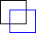 | 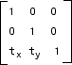 | t_{x} specifies the displacement along the x axis  t_{y} specifies the displacement along the y axis.
Scale |  | 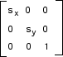 | s_{x} specifies the scale factor along the x axis  s_{y} specifies the scale factor along the y axis.
Shear |  | 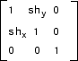 | sh_{x} specifies the shear factor along the x axis  sh_{y} specifies the shear factor along the y axis.
Rotation |  | 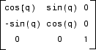 | q specifies the angle of rotation.

Using Sets of Points
Instead of specifying a transformation matrix, you optionally use sets of points to specify a transformation and let maketform infer the transformation matrix.
To do this for an affine transformation, you must pick three non-collinear points in the input image and in the output image. (The points form a triangle.) For a projective transformation, you must pick four points. (The points form a quadrilateral.)
This example picks three points in the input image and three points in the output image created by the translation performed in Example: Performing a Translation. The example passes these points to maketform and lets maketform infer the transformation matrix. The three points mark three corners of one of the checkerboard squares in the input image and the same square in the output image.
in_points = [11 11;21 11; 21 21]

out_points = [51 51;61 51;61 61]

tform2 = maketform('affine',inpts,outpts)

Creating TFORM Structures
After defining the transformation data (Defining the Transformation Data), you must create a TFORM structure to specify the spatial transformation. You use the maketform function to create a TFORM structure. You pass the TFORM structure to the imtransform to perform the transformation. (You can also create a TFORM using the cp2tform function. For more information, see Image Registration.)
The example creates a TFORM structure that specifies the parameters necessary for the translation operation.
tform_translate = maketform('affine',xform)
To create a TFORM you must specify the type of transformation you want to perform and pass in the transformation data. The example specifies 'affine' as the transformation type because translation is an affine transformation but maketform also supports projective transformations. In addition, by using the custom and composite options you can specify a virtually limitless variety of spatial transformations to be used with imtransform. The following table lists the transformation types supported by maketform.
Transformation Type | Description
'affine' | Transformation that can include translation, rotation, scaling, and shearing. Straight lines remain straight, and parallel lines remain parallel, but rectangles might become parallelograms.
'projective' | Transformation in which straight lines remain straight but parallel lines converge toward vanishing points. (The vanishing points can fall inside or outside the image -- even at infinity.)
'box' | Special case of an affine transformation where each dimension is shifted and scaled independently.
'custom' | User-defined transformation, providing the forward and/or inverse functions that are called by imtransform.
'composite' | Composition of two or more transformations.

Performing the Spatial Transformation
Once you specify the transformation in a TFORM struct, you can perform the transformation by calling imtransform. The imtransform function performs the specified transformation on the coordinates of the input image and creates an output image.
The translation example called imtransform to perform the transformation, passing it the image to be transformed and the TFORM structure. imtransform returns the transformed image.
cb_trans = imtransform(cb, tform_translate);
imtransform supports several optional input parameters that you can use to control various aspects of the transformation so as the size of the output image and the fill value used. To see an example of using the XData and YData input parameters, see Example: Performing Image Registration. For more information about specifying fill values, see Specifying Fill Values.

Specifying Fill Values
When you perform a transformation, there are often pixels in the output image that are not part of the original input image. These pixels must be assigned some value, called a fill value. By default, imtransform sets these pixels to zero and they are displayed as black. Using the FillValues parameter with the imtransform function, you can specify a different color.
Grayscale Images. If the image being transformed is a grayscale image, you must specify a scalar value that specifies a shade of gray.
For example, in Step 5: View the Output Image, where the example displays the translated checkerboard image in relation to the original coordinate space, you can specify a fill value that matches the color of the gray squares, rather than the default black color.
cb_fill = imtransform(cb, tform_translate,...
'XData', [1 (size(cb,2)+xform(3,1))],...
'YData', [1 (size(cb,1)+xform(3,2))],...
'FillValues', .7 );
figure, imshow(cb_fill)

Translated Image with Gray Fill Value
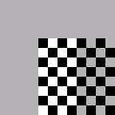
RGB Images. If the image being transformed is an RGB image, you can use either a scalar value or a 1-by-3 vector. If you specify a scalar, imtransform uses that shade of gray for each plane of the RGB image. If you specify a 1-by-3 vector, imtransform interprets the values as an RGB color value.
For example, this code translates an RGB image, specifying an RGB color value as the fill value. The example specifies one of the light green values in the image as the fill value.
rgb = imread('onion.png');
xform = [ 1 0 0
0 1 0
40 40 1 ]
tform_translate = maketform('affine',xform);
cb_rgb = imtransform(rgb, tform_translate,...
'XData', [1 (size(rgb,2)+xform(3,1))],...
'YData', [1 (size(rgb,1)+xform(3,2))],...
'FillValues', [187;192;57]);
figure, imshow(cb_rgb)

Translated RGB Image with Color Fill Value

If you are transforming multiple RGB images, you can specify different fill values for each RGB image. For example, if you want to transform a series of 10 RGB images, a 4-D array with dimensions 200-by-200-by-3-by-10, you have several options. You can specify a single scalar value and use a grayscale fill value for each RGB image. You can also specify a 1-by-3 vector to use a single color value for all the RGB images in the series. To use a different color fill value for each RGB image in the series, specify a 3-by-10 array containing RGB color values.

Performing N-Dimensional Spatial Transformations
The following functions, when used in combination, provide a vast array of options for defining and working with 2-D, N-D, and mixed-D spatial transformations:
- maketform
- fliptform
- tformfwd
- tforminv
- findbounds
- makeresampler
- tformarray
- imtransform
The imtransform, findbounds, and tformarray functions use the tformfwd and tforminv functions internally to encapsulate the forward transformations needed to determine the extent of an output image or array and/or to map the output pixels/array locations back to input locations. You can use tformfwd and tforminv to explore the geometric effects of a transformation by applying them to points and lines and plotting the results. They support a consistent handling of both image and pointwise data.
The following example, Performing the Spatial Transformation, uses the makeresampler function with a standard interpolation method. You can also use it to obtain special effects or custom processing. For example, you could specify your own separable filtering/interpolation kernel, build a custom resampler around the MATLAB interp2 or interp3 functions, or even implement an advanced antialiasing technique.
And, as noted, you can use tformarray to work with arbitrary-dimensional array transformations. The arrays do not even need to have the same dimensions. The output can have either a lower or higher number of dimensions than the input.
For example, if you are sampling 3-D data on a 2-D slice or manifold, the input array might have a lower dimensionality. The output dimensionality might be higher, for example, if you combine multiple 2-D transformations into a single 2-D to 3-D operation.
For example, this code uses imtransform to perform a projective transformation of a checkerboard image.
I = checkerboard(20,1,1);
figure; imshow(I)
T = maketform('projective',[1 1; 41 1; 41 41; 1 41],...
[5 5; 40 5; 35 30; -10 30]);
R = makeresampler('cubic','circular');
K = imtransform(I,T,R,'Size',[100 100],'XYScale',1);
figure, imshow(K)
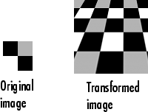
The imtransform function options let you control many aspects of the transformation. For example, note how the transformed image appears to contain multiple copies of the original image. This is accomplished by using the 'Size' option, to make the output image larger than the input image, and then specifying a padding method that extends the input image by repeating the pixels in a circular pattern. The Image Processing Toolbox Image Transformation demos provide more examples of using the imtransform function and related functions to perform different types of spatial transformations.

Example: Performing Image Registration
This example is intended to clarify the spatial relationship between the output image and the base image in image registration. The example illustrates use of the optional 'XData' and 'YData' input parameters and the optional xdata and ydata output values.

Step 1: Read in Base and Unregistered Images
Read the base and unregistered images from sample data files that come with the Image Processing Toolbox.
base = imread('westconcordorthophoto.png');
unregistered = imread('westconcordaerial.png');

Step 2: Display the Unregistered Image
Display the unregistered image.
iptsetpref('ImshowAxesVisible','on')
imshow(unregistered)
text(size(unregistered,2),size(unregistered,1)+30, ...
'Image courtesy of mPower3/Emerge', ...
'FontSize',7,'HorizontalAlignment','right');
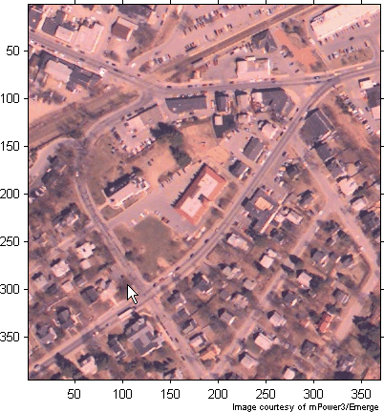

Step 3: Create a TFORM Structure
Create a TFORM structure using preselected control points. Start by loading a MAT-file that contains preselected control points for the base and unregistered images.
load westconcordpoints
tform = cp2tform(input_points, base_points, 'projective');

Step 4: Transform the Unregistered Image
Use imtransform to perform the transformations necessary to register the unregistered image with the base image. This code uses the optional FillValues input parameter to specify a fill value (white). This fill value helps when the example overlays the transformed image, registered, on the base image to check the registration in a later step.
registered = imtransform(unregistered, tform,...
'FillValues', 255);

Step 5: Overlay Registered Image Over Base Image
Overlay a semitransparent version of the registered image over the base image. Notice how the two images appear misregistered because the example assumes that the images are in the same spatial coordinate system. The next steps provide two ways to remedy this display problem.
figure; imshow(registered);
hold on
h = imshow(base, gray(256));
set(h, 'AlphaData', 0.6)

Registered Image with Base Image Overlay
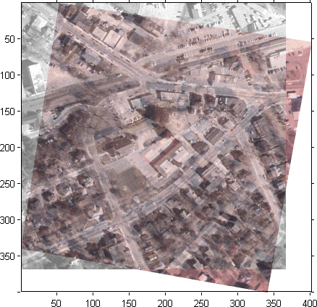

Step 5: Using XData and YData Input Parameters
One way to ensure that the registered image appears registered with the base image is to truncate the registered image by discarding any areas that would extrapolate beyond the extent of the base image. You use the 'XData' and 'YData' parameters to do this.
registered1 = imtransform(unregistered,tform,...
'FillValues', 255,...
'XData', [1 size(base,2)],...
'YData', [1 size(base,1)]);
Display the registered image, overlaying a semitransparent version of the base image for comparison. The registration is evident, but part of the unregistered image has been discarded. The next step provides another solution in which the entire registered image is visible.
figure; imshow(registered1)
hold on
h = imshow(base, gray(256));
set(h, 'AlphaData', 0.6)

Registered Image Truncated with Base Image Overlay
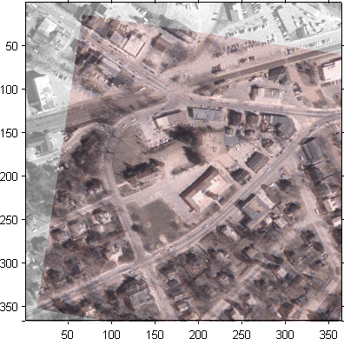

Step 6: Using XData and YData Output Values
Another approach is to compute the full extent of the registered image and use the optional imtransform syntax that returns the x- and y-coordinates that indicate the transformed image's position relative to the base image's pixel coordinates.
[registered2 xdata ydata] = imtransform(unregistered, tform,...
'FillValues', 255);
Display the registered image. Overlay a semi-transparent version of the base image for comparison. Adjust the axes to include the full base image. In this case, notice how the registration is evident and the full extent of both images is visible as well.
figure; imshow(registered2, 'XData', xdata, 'YData', ydata)
hold on
h = imshow(base, gray(256));
set(h, 'AlphaData', 0.6)
ylim = get(gca, 'YLim');
set(gca, 'YLim', [0.5 ylim(2)])
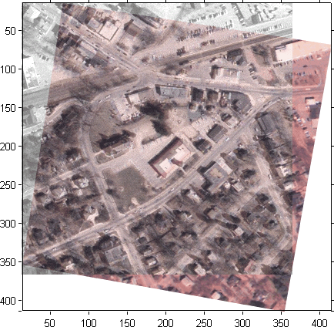

Linear Filtering
Filtering is a technique for modifying or enhancing an image. For example, you can filter an image to emphasize certain features or remove other features. Image processing operations implemented with filtering include smoothing, sharpening, and edge enhancement.
Filtering is a neighborhood operation, in which the value of any given pixel in the output image is determined by applying some algorithm to the values of the pixels in the neighborhood of the corresponding input pixel. A pixel's neighborhood is some set of pixels, defined by their locations relative to that pixel. (See Neighborhood and Block Operations for a general discussion of neighborhood operations.)
Linear filtering is filtering in which the value of an output pixel is a linear combination of the values of the pixels in the input pixel's neighborhood.
This section discusses linear filtering in MATLAB and the Image Processing Toolbox. It includes
- A description of filtering, using convolution and correlation.
- A description of how to perform filtering using the imfilter function
- A discussion about using predefined filter types
See Filter Design for information about how to design filters.

Convolution
Linear filtering of an image is accomplished through an operation called convolution. Convolution is a neighborhood operation in which each output pixel is the weighted sum of neighboring input pixels. The matrix of weights is called the convolution kernel, also known as the filter. A convolution kernel is a correlation kernel that has been rotated 180 degrees.
For example, suppose the image is
A = [17 24 1 8 15
23 5 7 14 16
4 6 13 20 22
10 12 19 21 3
11 18 25 2 9]
and the convolution kernel is
h = [8 1 6
3 5 7
4 9 2]
The following figure shows how to compute the (2,4) output pixel using these steps:
- Rotate the convolution kernel 180 degrees about its center element.
- Slide the center element of the convolution kernel so that it lies on top of the (2,4) element of A.
- Multiply each weight in the rotated convolution kernel by the pixel of A underneath.
- Sum the individual products from step 3.
Hence the (2,4) output pixel is

Computing the (2,4) Output of Convolution
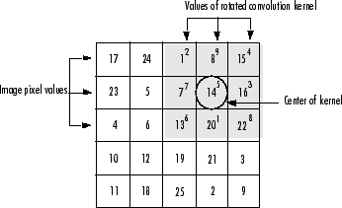

Correlation
The operation called correlation is closely related to convolution. In correlation, the value of an output pixel is also computed as a weighted sum of neighboring pixels. The difference is that the matrix of weights, in this case called the correlation kernel, is not rotated during the computation. The filter design functions in the Image Processing Toolbox return correlation kernels.
The following figure shows how to compute the (2,4) output pixel of the correlation of A, assuming h is a correlation kernel instead of a convolution kernel, using these steps:
- Slide the center element of the correlation kernel so that lies on top of the (2,4) element of A.
- Multiply each weight in the correlation kernel by the pixel of A underneath.
- Sum the individual products from step 3.
The (2,4) output pixel from the correlation is

Computing the (2,4) Output of Correlation
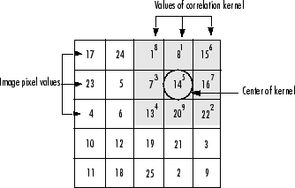

Filtering Using imfilter
Filtering of images, either by correlation or convolution, can be performed using the toolbox function imfilter. This example filters an image with a 5-by-5 filter containing equal weights. Such a filter is often called an averaging filter.
I = imread('coins.png');
h = ones(5,5) / 25;
I2 = imfilter(I,h);
imshow(I), title('Original Image');
figure, imshow(I2), title('Filtered Image')
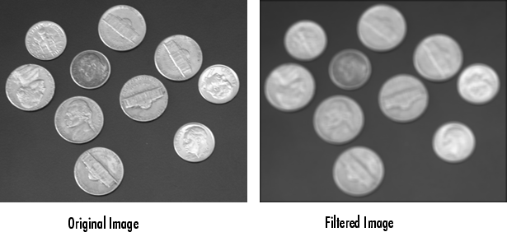

Data Types
The imfilter function handles data types similarly to the way the image arithmetic functions do, as described in Image Arithmetic Saturation Rules. The output image has the same data type, or numeric class, as the input image. The imfilter function computes the value of each output pixel using double-precision, floating-point arithmetic. If the result exceeds the range of the data type, the imfilter function truncates the result to that data type's allowed range. If it is an integer data type, imfilter rounds fractional values.
Because of the truncation behavior, you might sometimes want to consider converting your image to a different data type before calling imfilter. In this example, the output of imfilter has negative values when the input is of class double.
A = magic(5)

A =
17 24 1 8 15
23 5 7 14 16
4 6 13 20 22
10 12 19 21 3
11 18 25 2 9

h = [-1 0 1]

h =
-1 0 1

imfilter(A,h)

ans =
24 -16 -16 14 -8
5 -16 9 9 -14
6 9 14 9 -20
12 9 9 -16 -21
18 14 -16 -16 -2
Notice that the result has negative values. Now suppose A is of class uint8, instead of double.
A = uint8(magic(5));
imfilter(A,h)

ans =

24 0 0 14 0
5 0 9 9 0
6 9 14 9 0
12 9 9 0 0
18 14 0 0 0
Since the input to imfilter is of class uint8, the output also is of class uint8, and so the negative values are truncated to 0. In such cases, it might be appropriate to convert the image to another type, such as a signed integer type, single, or double, before calling imfilter.

Correlation and Convolution Options
The imfilter function can perform filtering using either correlation or convolution. It uses correlation by default, because the filter design functions, described in Filter Design, and the fspecial function, described in Using Predefined Filter Types, produce correlation kernels.
However, if you want to perform filtering using convolution instead, you can pass the string 'conv' as an optional input argument to imfilter. For example:
A = magic(5);
h = [-1 0 1]
imfilter(A,h) % filter using correlation

ans =
24 -16 -16 14 -8
5 -16 9 9 -14
6 9 14 9 -20
12 9 9 -16 -21
18 14 -16 -16 -2

imfilter(A,h,'conv') % filter using convolution

ans =

-24 16 16 -14 8
-5 16 -9 -9 14
-6 -9 -14 -9 20
-12 -9 -9 16 21
-18 -14 16 16 2

Boundary Padding Options
When computing an output pixel at the boundary of an image, a portion of the convolution or correlation kernel is usually off the edge of the image, as illustrated in the following figure.

When the Values of the Kernel Fall Outside the Image
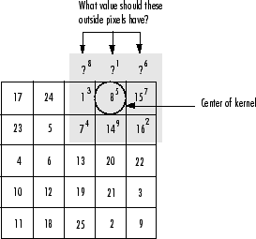
The imfilter function normally fills in these off-the-edge image pixels by assuming that they are 0. This is called zero padding and is illustrated in the following figure.

Zero Padding of Outside Pixels
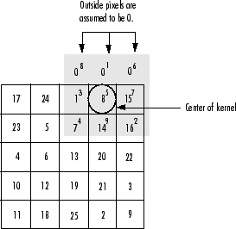
When you filter an image, zero padding can result in a dark band around the edge of the image, as shown in this example.
I = imread('eight.tif');
h = ones(5,5) / 25;
I2 = imfilter(I,h);
imshow(I), title('Original Image');
figure, imshow(I2), title('Filtered Image with Black Border')
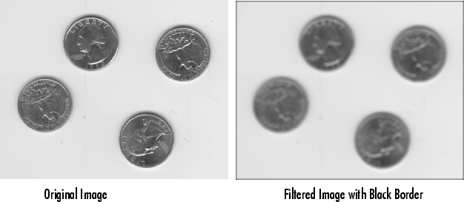
To eliminate the zero-padding artifacts around the edge of the image, imfilter offers an alternative boundary padding method called border replication. In border replication, the value of any pixel outside the image is determined by replicating the value from the nearest border pixel. This is illustrated in the following figure.

Replicated Boundary Pixels
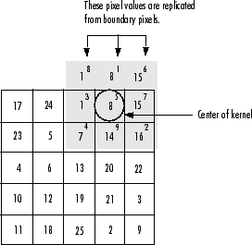
To filter using border replication, pass the additional optional argument 'replicate' to imfilter.
I3 = imfilter(I,h,'replicate');
figure, imshow(I3);
title('Filtered Image with Border Replication')
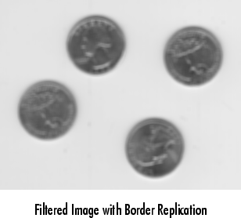
The imfilter function supports other boundary padding options, such as 'circular' and 'symmetric'. See the reference page for imfilter for details.

Multidimensional Filtering
The imfilter function can handle both multidimensional images and multidimensional filters. A convenient property of filtering is that filtering a three-dimensional image with a two-dimensional filter is equivalent to filtering each plane of the three-dimensional image individually with the same two-dimensional filter. This example shows how easy it is to filter each color plane of a truecolor image with the same filter:
- Read in an RGB image and display it.
- rgb = imread('peppers.png');
imshow(rgb);

- Filter the image and display it.
- h = ones(5,5)/25;
- rgb2 = imfilter(rgb,h);
figure, imshow(rgb2)


Relationship to Other Filtering Functions
MATLAB has several two-dimensional and multidimensional filtering functions. The function filter2 performs two-dimensional correlation, conv2 performs two-dimensional convolution, and convn performs multidimensional convolution. Each of these filtering functions always converts the input to double, and the output is always double. These other filtering functions always assume the input is zero padded, and they do not support other padding options.
In contrast, the imfilter function does not convert input images to double. The imfilter function also offers a flexible set of boundary padding options, as described in Boundary Padding Options.

Using Predefined Filter Types
The fspecial function produces several kinds of predefined filters, in the form of correlation kernels. After creating a filter with fspecial, you can apply it directly to your image data using imfilter. This example illustrates applying an unsharp masking filter to a grayscale image. The unsharp masking filter has the effect of making edges and fine detail in the image more crisp.
I = imread('moon.tif');
h = fspecial('unsharp');
I2 = imfilter(I,h);
imshow(I), title('Original Image')
figure, imshow(I2), title('Filtered Image')
